APPENDIX A

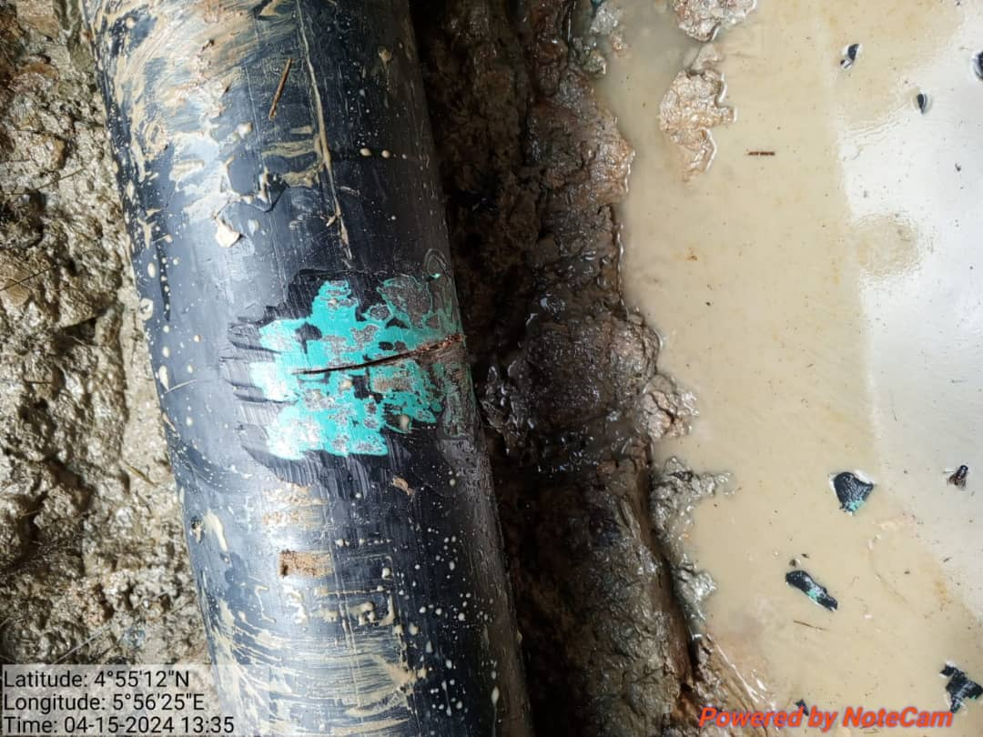
Figure 1: After exposure of the incident point

